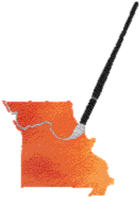
Michael Bailey, AWS, NWS
Workshop
In conjunction with the MOWS 2019 International Exhibition
Four day workshop June 24th through June 27th
Held at the St. Louis Artists Guild in St. Louis/Clayton, Missouri
Mike Bailey resides in Santa Cruz, CA. He is a nationally and internationally recognized award-winning watercolorist. Educated in Engineering and Business at San Jose State University, he took up painting in mid-career – to relieve the stress as a high-tech marketing executive. It very shortly became a ‘passion’.
He has exhibited his work in Shanghai, New York City, France and Spain as well as throughout the US. His work has been published in books and magazines and is held in collections throughout the US, Europe and Australia. He is an accomplished plein air painter as well as a renown studio artist.
R

REGISTRATION

Name________________________________ Address ________________________________
Phone _______________________________ Cell phone ______________________________
Email address ___________________________________________________________________
Cost $350 MOWS Members $375 MOWS non-members $100 deposit required - fully refundable until May 1, 2019.
PLEASE send the Registration and deposit to: MOWS 1410 S. 18th Street, St. Louis, MO 63104

